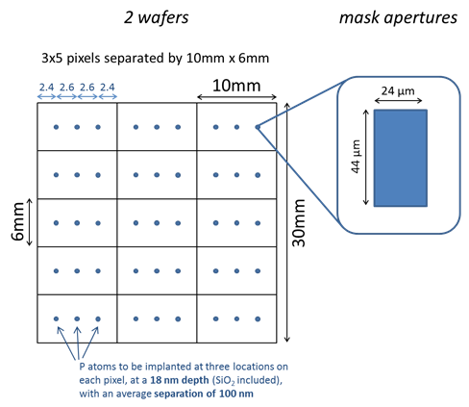

100nm separation correspond to a fluence of 1e10cm-2

18nm depth correspond to 11keV implant energy